Strengthening Wellbeing through Respite

Core Team Member Self-Assessment Worksheet

Name: ______________________________________ Date of Self-Assessment: _______________
This worksheet is for staff on Continuum Core Teams to assess their own practice in preparation for meeting with their Program Director. Use the Strengthening Wellbeing through Respite Core Element of the Practice Profile to identify both the strengths and areas needing improvement in your practice. Please read the description of the Core Element all the way through so you can get a sense of what the practice looks like as a “whole.” Make note (you may highlight, underline or circle) of specific items that reflect your current practice, then assess your practice for each sub-category using a rating scale of 1 to 10 as defined below. Record your rating for each sub-category and provide examples of strengths and areas needing improvement on this worksheet.

10 | Ideal practice proficiency | My practice in this area demonstrates a consistently high degree of mastery in a wide range of situations and with all families, children, and youth.
5 | Developmental practice proficiency | My practice in this area demonstrates a good understanding and skill level. My practice is strong, but only in some situations and with some families, children, and youth.
1 | Unsatisfactory practice proficiency | This is a new or emerging skill for me. It is not yet present in my practice
0 | N/A | This practice is not part of my responsibilities on the Continuum Team.

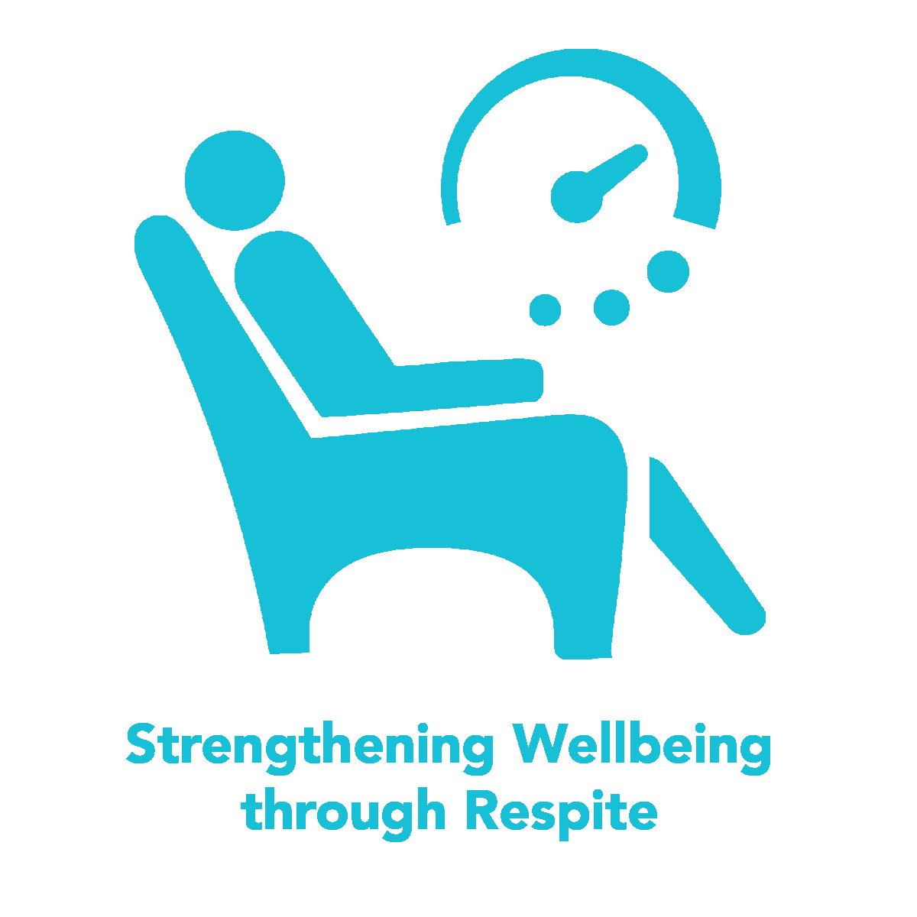

Practice Sub-category | My Practice Rating | Practice Strengths | Practices Needing Improvement
Orienting parents/caregivers and youth to respite

Exploring respite needs

Supporting parent / caregiver, youth, and family team in planning / coordinating respite

Ensuring provision of youth respite care

Debriefing respite care experience

Items for discussion

